Data Collection

|  |  |
| --- | --- |
| Date | 13 November 2022 |
| Team ID | PNT2022TMID13897 |
| Project Name | AI-powered nutrition analyzer for fitness enthusiasts |
| Maximum Marks | 6 Marks |

# Data Collection

Collect images of different food items organized into subdirectories based on their respective names as shown in the project structure.

# Project structure sample:

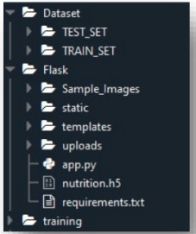Create folders of types of food items that need to be recognized.

In this project, we have collected images of 5 types of food items apples, 'banana', 'orange', 'pineapple' and 'watermelon', they are saved in the respective subdirectories with their respective names.

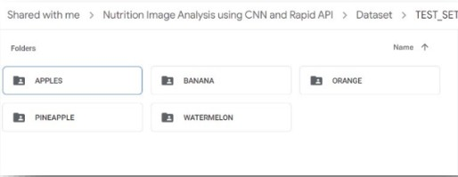

For more accurate results we can collect images of high resolution and feed the model with more images.